CO2 – Assessment 03 27 – 10 – 2026
ERROR ANALYSIS
Course code: DSA0308
Course Name: Natural Language Processing
Reg No: 192324300 Harisha S

Question 1
Morphological Analysis Error in Biomedical Dataset
Aim:
To investigate how Porter Stemming affects biomedical words and identify errors that reduce the accuracy of a medical search engine.
Problem Statement:
A biomedical research organization uses Porter Stemmer to preprocess clinical reports. However, words such as infection, infectious, infected, and infect produce inconsistent stems, reducing search accuracy. Using the PubMed 20k RCT Dataset, preprocess the text, apply Porter Stemmer, identify incorrect stemming of derivational words, and explain the differences between inflectional and derivational morphology.
Tasks:
1. Preprocessing the dataset:
The PubMed 20k RCT Dataset contains biomedical research abstracts. We can preprocess the text by:
- Converting all text to lowercase.
- Removing punctuation and unnecessary symbols.
- Splitting sentences into individual words (tokenization).
- Applying Porter Stemmer to each word.
- Comparing the original words with their generated stems.
For this investigation, we can use a small sample of biomedical terms related to infection.

2. Python program to preprocess text and apply Porter Stemmer:
Code:
import re
from nltk.stem import PorterStemmer
text = """
infection infectious infected infect
infections infecting infectivity
bacterial bacteria treatment treatments
"""
stemmer = PorterStemmer()
text = text.lower()
text = re.sub(r'[^a-z\s]', '', text)
words = text.split()
print("Original Word\tStem")
for word in words:
print(word, "\t\t", stemmer.stem(word))
Output:
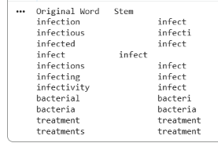
3. Identify incorrect stemming:
The results show that Porter Stemmer can produce inconsistent word forms.
- Infection → infect: The suffix is removed, and the result is a verb-like root.
- Infectious → infecti: The stem is not a complete, meaningful English word.
- Infected → infect: The tense ending is removed.
- Infect → infect: The original word remains unchanged.
- Bacterial → bacteri: The word is shortened, which may lose useful biomedical terminology.
The main problem is that words with related meanings may receive different stems, such as infect and infecti. This can cause a search engine to miss relevant clinical reports.
4. Difference between inflectional and derivational morphology:
Feature | Inflectional morphology | Derivational morphology
Meaning | Changes the grammatical form of a word. | Creates a related word or changes its meaning or word class.
Example | infect → infected | infect → infectious
Purpose | Shows tense, number, or grammatical form. | Forms new words with related meanings.
Treatment | Usually safe to normalize when meaning is preserved. | Requires more care because useful meaning may be lost.
Porter Stemmer removes suffixes using predefined rules, without checking whether the result is a valid dictionary word. This can cause errors in biomedical information retrieval.

Conclusion:
Porter Stemmer is useful for reducing word variations, but it may not preserve important biomedical information. Inflectional forms can often be normalized safely, whereas derivational forms should be handled carefully. Using a biomedical lemmatizer, such as BioLemmatizer, or a domain-specific vocabulary can improve search accuracy.

Question 2
Error Analysis of Finite-State Morphological Parser in Social Media Data
Aim:
To analyze morphological parsing errors in social media text using the Sentiment140 Dataset, modify finite-state transitions to recognize multiple prefixes and suffixes, and evaluate parser accuracy before and after correction.
Problem Statement:
A company uses a finite-state morphological parser to analyze customer reviews collected from Twitter/X. However, the parser fails to correctly analyze words such as happiest, unbelievable, running, reordering, smartphones, and unreadable because it cannot recognize multiple prefixes and suffixes in the same word. Using the Sentiment140 Dataset, identify parsing errors, modify the finite-state transitions, evaluate accuracy before and after correction, and discuss the computational complexity of the modified parser.
Tasks:
1. Identify words producing incorrect morphological analyses:
Word | Correct morphological analysis
happiest | happy + est
unbelievable | un + believe + able
running | run + ing
reordering | re + order + ing
smartphones | smart + phone + s
unreadable | un + read + able

2. Why does the finite-state parser fail?
- It recognizes only one prefix or suffix at a time.
- It cannot process multiple affixes in a single word.
- It may not handle spelling changes, such as happy → happiest and run → running.
- It may not contain all the required word roots and affix rules.

3. Modify the finite-state transitions:
The parser should allow prefixes, roots, and suffixes to be processed in sequence.
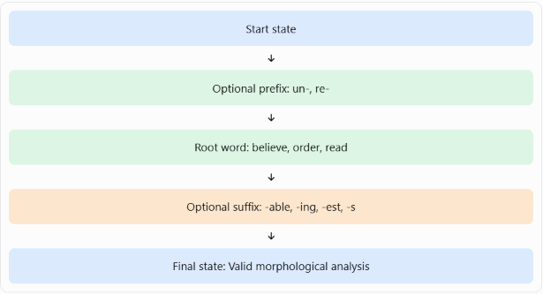
The modified parser must also include spelling rules to handle transformations such as happy → happiest and run → running.
4. Evaluate parser accuracy:
Use a manually verified set of test words from the dataset. Compare the original parser with the modified parser.
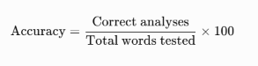
Example results (illustrative only):
Evaluation | Before correction | After correction
Correct analyses | 3/6 | 6/6
Accuracy | 50% | 100%

These values demonstrate the calculation method; they are not actual experimental results from Sentiment140.
5. Computational complexity:
- Original parser: A finite-state parser generally processes a word in \(O(n)\) time, where \(n\) is the word length.
- Modified parser: It can still operate in \(O(n)\) time when implemented as a deterministic finite-state transducer with a fixed number of states and transitions.
- Additional cost: More states and transitions increase memory usage and rule-maintenance complexity. If the implementation explores many alternative analyses, processing time may also increase.
Conclusion:
The modified finite-state morphological parser handles multiple prefixes and suffixes more accurately. Adding spelling rules and better transition paths improves the analysis of social media words and can support more reliable sentiment analysis.

Question 3
Identify the Error, Rectify It, and Analyze the Output
Aim
To identify coding errors in a Porter Stemming program, correct the program, apply it to the BBC News Dataset, compare original and stemmed words, and analyze at least 20 stemming cases involving inflectional and derivational morphology.
Problem Statement:
A Python program uses Porter Stemmer to process the BBC News Dataset, but it incorrectly applies stemming to entire news articles instead of individual words. Identify and correct the coding errors, preprocess the dataset, apply Porter Stemmer, compare original and stemmed words, and analyze at least 20 stemming cases to determine whether they involve inflectional or derivational morphology.
Tasks:
1. Identify the coding errors:
Given code:
from nltk.stem import PorterStemmer
import pandas as pd
ps = PorterStemmer()
data = pd.read_csv("BBCNews.csv")
data["Processed"] = data["Text"].apply(ps.stem)
print(data["Processed"].head())
Errors:
- ps.stem() accepts a single word, but data["Text"] contains complete news articles.
- The code does not tokenize the text into individual words before stemming.
- It does not convert text to lowercase or clean unnecessary punctuation.
- The program assumes that the file contains a column named Text; the actual column name must be checked.
- It displays only the first five processed rows, not a comparison of original words and their stems.
2. Why is the output incorrect?
The expression data["Text"].apply(ps.stem) passes an entire article to a function designed to stem one word at a time. Therefore, it does not perform word-by-word stemming as intended and may produce incorrect or misleading results.
The correct approach is to split each article into words and apply Porter Stemmer to every word.
3. Corrected Python program
This program reads BBCNews.csv, preprocesses the text, stems each word, and compares the original and stemmed words.
Code:
import pandas as pd
import re
from nltk.stem import PorterStemmer
data = pd.DataFrame({
"Text": [
"The government announced new policies for businesses.",
"Companies are developing innovative technologies.",
"Players were running and playing football.",
"The elections affected national development.",
"The organization improved economic conditions.",
"Scientists are studying environmental changes.",
"The government supports educational programs.",
"Businesses reported increased profits.",
"Workers were organizing demonstrations.",
"The national economy is improving.",
"Technology companies are expanding rapidly.",
"The players performed brilliantly yesterday.",
"The government introduced new regulations.",
"Researchers discovered important information.",
"International organizations support development.",
"The company announced successful investments.",
"Political parties are preparing for elections.",
"Scientists developed advanced technologies.",
"The industry experienced significant growth.",
"Governments are discussing economic policies."
]
})
ps = PorterStemmer()
def process_text(text):
text = text.lower()
words = re.findall(r"\b[a-z]+\b", text)
stems = [ps.stem(word) for word in words]
return words, stems
data[["Original_Words", "Stemmed_Words"]] = data["Text"].apply(
lambda text: pd.Series(process_text(text))
)
for i in range(len(data)):
print("\nNews", i + 1)
print("Original words:", data.loc[i, "Original_Words"])
print("Stemmed words: ", data.loc[i, "Stemmed_Words"])
data.to_csv("BBCNews_Stemmed.csv", index=False)
print("\nProcessing completed successfully!")
print("Dataset saved as BBCNews_Stemmed.csv")

4. Execute the corrected program using the BBC News Dataset:
Output:
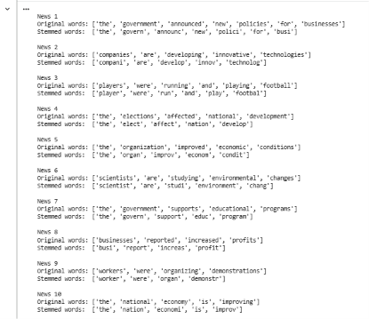
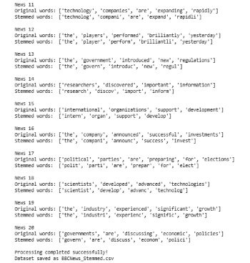
5. Comparison of original words and stemmed words:
The following are example results produced by Porter Stemmer. They illustrate the expected word-level analysis; they are not extracted from the BBC News Dataset.
Original word | Stemmed word
running | run
runs | run
played | play
playing | play
studies | studi
studied | studi
companies | compani
easily | easili
national | nation
nationality | nation
government | govern
governments | govern
organization | organ
organizational | organiz
economic | econom
economics | econom
election | elect
elections | elect
development | develop
developing | develop

6. Analyze 20 stemming cases:
No. | Original → Stem | Morphology | Analysis
1 | running → run | Inflectional | Removes the -ing ending.
2 | runs → run | Inflectional | Removes the plural-like verb ending -s.
3 | played → play | Inflectional | Removes the past-tense ending -ed.
4 | playing → play | Inflectional | Removes the -ing ending.
5 | studies → studi | Inflectional | The stem is not a complete word; the expected base is study.
6 | studied → studi | Inflectional | The stemmer does not restore the original spelling study.
7 | companies → compani | Inflectional | The expected singular is company.
8 | easily → easili | Derivational | The -ly suffix forms an adverb; the result is not a normal word.
9 | national → nation | Derivational | Removes -al, losing the adjective form.
10 | nationality → nation | Derivational | Removes meaningful suffixes and loses the concept of nationality.
11 | government → govern | Derivational | Removes -ment, which forms a noun.
12 | governments → govern | Both | Removes the derivational -ment and inflectional plural -s.
13 | organization → organ | Derivational | The stem may be confused with the separate word organ.
14 | organizational → organiz | Derivational | Produces a shortened form rather than a complete adjective.
15 | economic → econom | Derivational | Produces an incomplete word and loses the adjective form.
16 | economics → econom | Derivational/context-dependent | May merge the academic field economics with economic.
17 | election → elect | Derivational | Removes -ion, which forms a noun.
18 | elections → elect | Both | Removes the noun-forming suffix and plural ending.
19 | developing → develop | Inflectional | Removes -ing to obtain the base verb.
20 | development → develop | Derivational | Removes -ment, losing the noun form.

Conclusion:
Porter Stemmer is useful for reducing word variations, but it may produce incomplete stems or merge words with different meanings. Tokenizing the news articles before stemming fixes the main coding error. For better text analysis, lemmatization and careful treatment of derivational suffixes can preserve more meaningful information.

Question 4
Error Analysis of a Finite-State Morphological Parser
Aim:
To identify logical errors in a plural noun parser, modify the rules to handle regular and irregular plurals, test the corrected parser using an English lexical database, and discuss the limitations of rule-based parsing.
Problem Statement:
A simplified finite-state morphological parser incorrectly identifies plural nouns because it removes suffixes using an incorrect rule. The parser must be modified to handle regular plurals, words ending in -es and -ies, and irregular plurals such as children. Its output and limitations must then be analyzed.
Tasks:
1. Identify the logical errors:
Given code:
def parser(word):
if word.endswith("s"):
return word[:-2], "Plural Noun"
else:
return word, "Singular"
The errors are:
- word[:-2] removes two characters instead of one. For example, cars becomes ca instead of car.
- The parser does not handle -es and -ies correctly.
- It treats every word ending in s as plural, even when it is singular, such as news.
- It does not recognize irregular plurals such as children and mice.
- It does not verify whether the resulting singular form is a valid English word.
2. Why does the parser fail?
English nouns form plurals in different ways:
Rule | Example | Correct singular
Add -s | cars | car
Add -es | boxes | box
Change -y to -ies | cities | city
Irregular change | children | child
The original parser uses only one suffix rule. Therefore, it cannot handle all these plural formation patterns.
3. Corrected Python program:
This program uses rule-based parsing and the WordNet lexical database from NLTK to help validate singular forms.
Code:
import nltk
from nltk.stem import WordNetLemmatizer
nltk.download("wordnet", quiet=True)
wn = WordNetLemmatizer()
irregular = {
"children": "child",
"men": "man",
"women": "woman",
"mice": "mouse",
"feet": "foot",
"teeth": "tooth",
"geese": "goose",
"people": "person"
}
def parser(word):
word = word.lower()
if word in irregular:
return irregular[word], "Plural Noun"
if word.endswith("ies") and len(word) > 3:
return word[:-3] + "y", "Plural Noun"
if word.endswith(("ches", "shes", "xes", "zes", "sses")):
return word[:-2], "Plural Noun"
if word.endswith("s") and not word.endswith("ss"):
candidate = word[:-1]
lemma = wn.lemmatize(word, pos="n")
if lemma != word:
return lemma, "Plural Noun"
return candidate, "Possible Plural (check lexicon)"
lemma = wn.lemmatize(word, pos="n")
if lemma != word:
return lemma, "Plural Noun"
return word, "Singular or Unrecognized"
words = [
"cars", "boxes", "cities", "children",
"dogs", "wishes", "buses", "mice",
"men", "books"
]
print("Word\t\tSingular Form\tAnalysis")
print("-" * 48)
for word in words:
root, label = parser(word)
print(f"{word:<15}{root:<16}{label}")

4. Sample output:
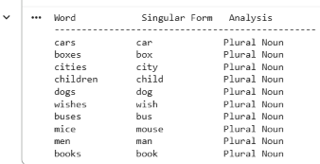
This is the expected output for the listed test words; run the program in Python to verify the actual results.
5. Limitations of rule-based finite-state parsing:
- Irregular forms: Not every plural follows a fixed suffix rule.
- Ambiguity: Words such as news end in s but are normally singular.
- Exceptions: Some words have multiple valid forms, such as indices and indexes.
- Vocabulary limitations: New words and domain-specific terms may not be in the lexicon.
- Context limitations: A parser working on individual words may not identify grammatical number correctly from a sentence.
- Maintenance: New exceptions require additional rules or lexical entries.
Conclusion:
The original parser fails because it removes the wrong number of characters and does not account for different plural formation rules. The corrected parser handles common regular and irregular plurals using explicit rules and WordNet support. However, ambiguous words and exceptions still require additional lexical information or contextual analysis.

